AWS Relation Database Service – RDS

# Relation Database Service – RDS Overview

* Amazon Relational Database Service (RDS) is a web service that makes it easier to set up, operate, and scale a relational database in the cloud.
* RDS provides cost-efficient, resizable capacity for an industry-standard relational database and manages common database administration tasks.
* RDS features & benefits
  + CPU, memory, storage, and IOPs can be scaled independently.
  + manages backups, software patching, automatic failure detection, and recovery.
  + automated backups can be performed as needed, or manual backups can be triggered as well. Backups can be used to restore a database, and the RDS restore process works reliably and efficiently.
  + provides high availability with a primary instance and a synchronous standby secondary instance that can be failovered to seamlessly when a problem occurs.
  + provides elasticity & scalability by enabling Read Replicas to increase read scaling.
  + supports MySQL, MariaDB, PostgreSQL, Oracle, Microsoft SQL Server, and the new, MySQL-compatible Amazon Aurora DB engine
  + supports IAM users and permissions to control who has access to the RDS database service
  + databases can be further protected by putting them in a VPC, using SSL for data in transit and encryption for data in rest
  + However, **as it is a managed service, shell (root ssh) access to DB instances is not provided**, and this restricts access to certain system procedures and tables that require advanced privileges.

## RDS Components

* **DB Instance**
  + is a basic building block of RDS
  + is an isolated database environment in the cloud
  + each DB instance runs a DB engine. AWS currently supports MySQL, MariaDB, PostgreSQL, Oracle, and Microsoft SQL Server & Aurora DB engines
  + can be accessed from AWS command line tools, RDS APIs, or the AWS Management RDS Console.
  + computation and memory capacity of an DB instance is determined by its DB instance class, which can be selected as per the needs
  + for each DB instance, 5 GB to 6 TB of associated storage capacity can be selected
  + storage comes in three types: Magnetic, General Purpose (SSD), and Provisioned IOPS (SSD), which differ in performance characteristics and price
  + each DB instance has a DB instance identifier, which is customer-supplied name and must be unique for that customer in an AWS region. It uniquely identifies the DB instance when interacting with the RDS API and AWS CLI commands.
  + each DB instance can host multiple databases, or a single Oracle database with multiple schemas.
  + can be hosted in an AWS VPC environment for better control
* **Regions and Availability Zones**
  + AWS resources are housed in highly available data center facilities in different areas of world, these data centers are called regions which further contain multiple distinct locations called Availability Zones
  + Each AZ is engineered to be isolated from failures in other AZs, and to provide inexpensive, low-latency network connectivity to other AZs in the same region
  + DB instances can be hosted in different AZs, an option called a Multi-AZ deployment.
    - Amazon automatically provisions and maintains a **synchronous** standby replica of the DB instance in a different AZ.
    - Primary DB instance is synchronously replicated across AZs to the standby replica
    - Provides data redundancy, failover support, eliminate I/O freezes, and minimize latency spikes during system backups.

* **Security Groups**
  + security group controls the access to a DB instance, by allowing access to the specified IP address ranges or EC2 instances
* **DB Parameter Groups**
  + A DB parameter group contains engine configuration values that can be applied to one or more DB instances of the same instance type
  + help define configuration values specific to the selected DB Engine for e.g. max_connections, force_ssl, autocommit
  + supports default parameter group, which cannot be edited.
  + supports custom parameter group, to override values
  + supports static and dynamic parameter groups
    - changes to dynamic parameters are applied immediately (irrespective of apply immediately setting)
    - changes to static parameters are **NOT** applied immediately and require a manual reboot.
* **DB Option Groups**
  + Some DB engines offer tools or optional features that simplify managing the databases and making the best use of data.
  + RDS makes such tools available through option groups for e.g. Oracle Application Express (APEX), SQL Server Transparent Data Encryption, and MySQL memcached support.

## 

## RDS Interfaces

* RDS can be interacted with multiple interfaces
  + AWS RDS Management console
  + Command Line Interface
  + Programmatic Interfaces which include SDKs, libraries in different languages, and RDS API

## RDS Pricing

* Instance class
  + Pricing is based on the class (e.g., micro, small, large, xlarge) of the DB instance consumed.
* Running time
  + Billed by the instance-hour, which is equivalent to a single instance running for an hour for e.g., a single instance running for two hours = two instances running for one hour, both consume 2 instance-hours.
  + if a DB instance runs for only part of an hour, full instance-hour is charged
* Storage
  + Storage capacity provisioned for the DB instance is billed per GB per month
  + If the provisioned storage capacity is scaled within the month, the bill will be pro-rated.
* I/O requests per month
  + Total number of storage I/O requests made in a billing cycle.
* Backup storage
  + Automated backups & any active database snapshots consume storage
  + Increasing backup retention period or taking additional database snapshots increases the backup storage consumed by the database.
  + RDS provides backup storage up to 100% of the provisioned database storage at no additional charge for e.g., if you have 10 GB-months of provisioned database storage, RDS provides up to 10 GB-months of backup storage at no additional charge.
  + Most databases require less raw storage for a backup than for the primary dataset, so if multiple backups are not maintained, you will never pay for backup storage.
  + Backup storage is free only for active DB instances.
* Data transfer
  + Internet data transfer in and out of your DB instance.
* Reserved Instance
  + In addition to regular RDS pricing, reserved DB instances can be purchased

### 

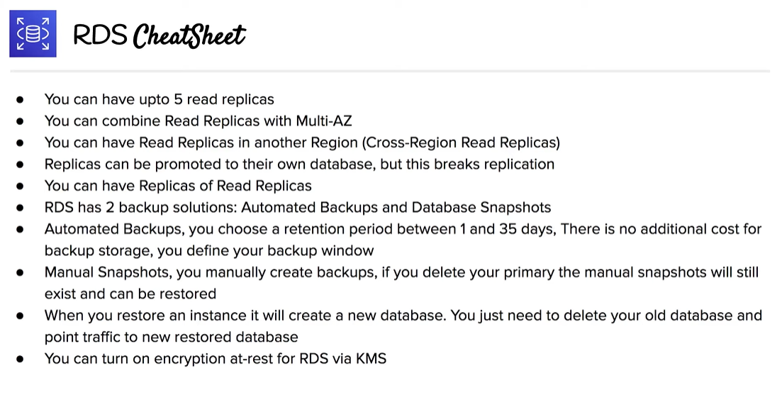

### Further Reading

* [RDS Multi-AZ and Read Replica](https://jayendrapatil.com/aws-rds-replication-multi-az-read-replica/)
* [RDS Storage](https://jayendrapatil.com/aws-rds-storage/)
* [RDS Snapshots, Backup & Restore](https://jayendrapatil.com/aws-rds-db-snapshot-backup-restore/)
* [RDS Security](https://jayendrapatil.com/aws-rds-security/)
* [RDS Maintenance & Upgrades](https://jayendrapatil.com/aws-rds-db-maintenance-upgrades/)
* [RDS Monitoring & Notification](https://jayendrapatil.com/aws-rds-monitoring-notification/)

## AWS Certification Exam Practice Questions

1. What does Amazon RDS stand for?
   1. Regional Data Server.
   2. **Relational Database Service**
   3. Regional Database Service.
2. How many relational database engines does RDS currently support?
   1. **MySQL, Postgres, MariaDB, Oracle and Microsoft SQL Server**
   2. Just two: MySQL and Oracle.
   3. Five: MySQL, PostgreSQL, MongoDB, Cassandra and SQLite.
   4. Just one: MySQL.
3. If I modify a DB Instance or the DB parameter group associated with the instance, should I reboot the instance for the changes to take effect?
   1. No
   2. **Yes**
4. What is the name of licensing model in which I can use your existing Oracle Database licenses to run Oracle deployments on Amazon RDS?
   1. **Bring Your Own License**
   2. Role Bases License
   3. Enterprise License
   4. License Included
5. Will I be charged if the DB instance is idle?
   1. No
   2. **Yes**
   3. Only is running in GovCloud
   4. Only if running in VPC
6. What is the minimum charge for the data transferred between Amazon RDS and Amazon EC2 Instances in the same Availability Zone?
   1. USD 0.10 per GB
   2. **No charge. It is free.**
   3. USD 0.02 per GB
   4. USD 0.01 per GB
7. Does Amazon RDS allow direct host access via Telnet, Secure Shell (SSH), or Windows Remote Desktop Connection?
   1. Yes
   2. **No**
   3. Depends on if it is in VPC or not
8. What are the two types of licensing options available for using Amazon RDS for Oracle?
   1. BYOL and Enterprise License
   2. **BYOL and License Included**
   3. Enterprise License and License Included
   4. Role based License and License Included
9. A user plans to use RDS as a managed DB platform. Which of the below mentioned features is not supported by RDS?
   1. Automated backup
   2. **Automated scaling to manage a higher load**
   3. Automated failure detection and recovery
   4. Automated software patching
10. A user is launching an AWS RDS with MySQL. Which of the below mentioned options allows the user to configure the InnoDB engine parameters?
    1. Options group
    2. Engine parameters
    3. **Parameter groups**
    4. DB parameters
11. A user is planning to use the AWS RDS with MySQL. Which of the below mentioned services the user is not going to pay?
    1. Data transfer
    2. **RDS CloudWatch metrics**
    3. Data storage
    4. I/O requests per month